DADS WAR 1939 - 1945

The outbreak of World War 2 created a deep sense of fatalism, and despair. A large proportion of the population, ones relations, and indeed everybody one knew, had lived through the mass slaughter of World War 1, and it had become normal to refer to some loved one as having been killed in the war. I was one of a generation scheduled to suffer the same fate. There did not seem to be any future.

The fact that I became a Radio Amateur in 1938 with the call sign G2HCG had a very great effect on my wartime activities. A number of my radio friends had joined the Royal Naval Wireless Reserve, and rather foolishly, I had joined them.

The outbreak of war resulted in my transmitting equipment being collected by the Post Office and stored safely, for return after the war. (I did actually get it back) There was one very interesting BBC broadcast, and newspaper advertisement, that changed everything. They were asking for Radio Amateurs to join the RAF to operate specialised radio equipment. There was the incentive that recruits, already having radio knowledge, would be granted the rank of LAC – leading aircraftman, which was a double promotion from the lower ranks of Aircraftman. It seemed that I was going to be called up anyway, and the technical side of things looked interesting so I volunteered to join this mysterious technical air force.

I received notification in September to report to Cardington for initial training. It was interesting that before I actually went to Cardington, a call up notice from the Navy appeared in the post as a result of my membership of the Naval reserve. I happily refused this on the basis that I had already joined the RAF. I learned later that had I joined the Navy, I would have been wireless op. on a minesweeper in the North Sea with a life expectancy measured in weeks.

Cardington was certainly a wake up, after the somewhat sheltered life of an “Only child”. It was the usual square bashing and general apparent waste of time. The knowledge of the intricacies, which are surprisingly complicated, of controlling a marching squad of men, did come in useful later when I had to do that job as an NCO. However, the need for technical knowledge was urgent and within 14 days, I was posted to Staxton in the north of England.

STAXTON
Staxton appeared to be a large radio station with four 360ft steel towers and four 240ft wooden towers together with a number of bomb proof blocks containing transmitters and receivers.

Upon arrival myself and another radio recruit were escorted to the CO’s office and given a lecture on the need for extreme secrecy in our future activities. An official swearing in of what appeared to be the official secrets act followed. This secrecy was totally paramount and exceeded even orders from a senior officer. I did enjoy myself much later when the occasion arose when some Top Brass ordered me to tell them about what I did.

This station was known as a CH station, the letters standing for Chain Home, and was part of a chain of such stations along the east and south coasts of the UK. After the official secrecy proceedings, I was taken into the receiver room. . This was in a bombproof block surrounded by substantial blast walls, near to the four wooden towers. All equipment was duplicated and consisted of large 6 ft. racks culminating in operating positions with a large Cathode Ray Tube and a WAAF operator. I learnt to my total astonishment that these operators were actually plotting the position of all aircraft within some 100 miles East of the station, and passing that knowledge to a central filter room near London.
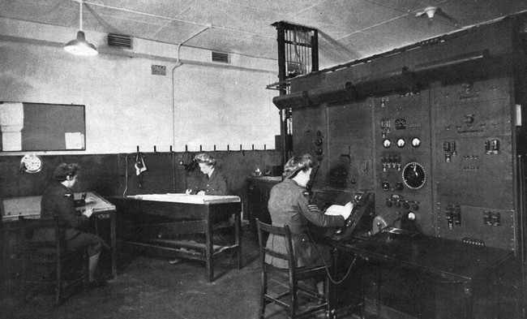

Receiver Room

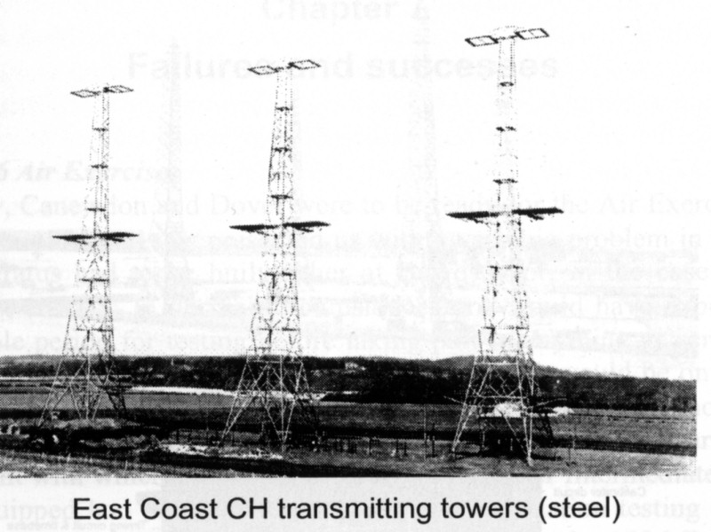

The next visit was the transmitter hall some quarter of a mile away, also bombproof and near to the four steel transmitting towers. The hall contained two giant Metro Vickers transmitters and associated control desks. I was designated a Radio Mechanic and this was to be my work place, with a 24 hour watch system.

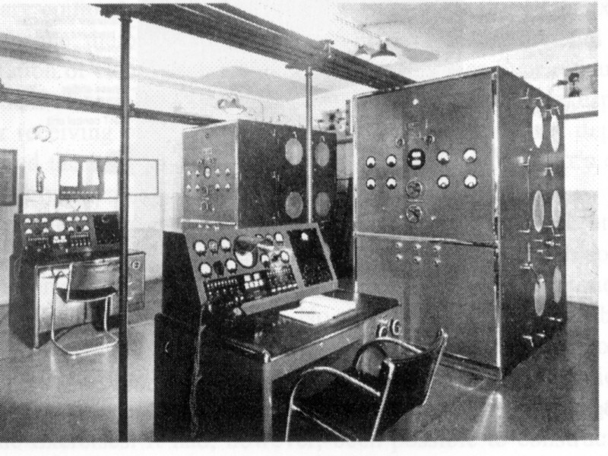

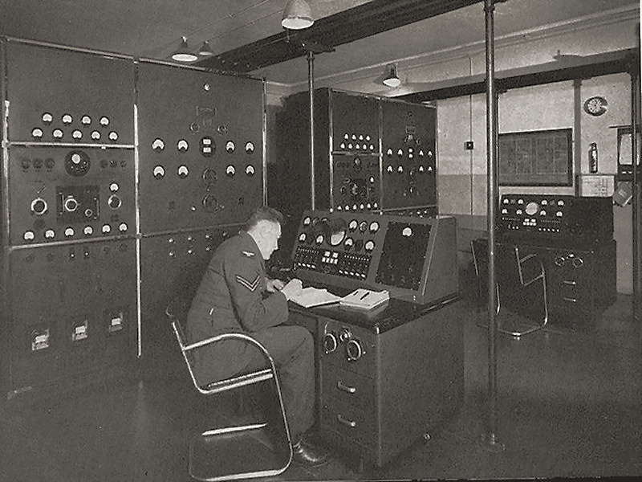
At this stage I had received no training in the technicalities of the transmitters, but I was still expected to be part of a watch of 2 persons in charge of this array of equipment. The powers that be had acted wisely in choosing radio amateurs, they had already passed a technical exam, and after all a transmitter is a transmitter regardless of size, and I knew what the meters, and knobs did, even though the readings to say the least, were somewhat higher to those on my own equipment. We were handling pulse powers of some 200 Kw.

We normally operated a 3 watch system - 8 hours on and 16 hours off. Occasionally when we had enough personnel, we could run a 4 watch system with 6 hours on and 18 off., with various permutations involving 24 hours off. This was luxury indeed. Watch keeping resulted in a brush with RAF discipline. I had been on the night watches, which meant sleeping during the day. It so happened that some top brass with nothing better to do, descended on us for a snap inspection, and I was found sleeping in my bunk. The brass objected to someone sleeping when "their majesties" were inspecting, and I was "put on a charge" - to have it annulled later by the local CO.

. The stations were know as RDF stations. Radio Direction Finding was a well known procedure, relying on transmissions from the aircraft to provide the bearing. This of course was nullified if the aircraft kept radio silence. The CH stations operated by covering the space over the sea in front of them with a blanket of high power radio waves, and measuring the bearing of any reflections from any object, aircraft, or ship, using standard well known DF procedures. Measuring the bearing is fine, but to provide a position, one also needs the distance, and this was the secret of Radio Location, as it was first called. In the interest of brevity, I shall talk of Radar as the Americans later named it. The measurement of distance was achieved by transmitting a very short high power radio pulse, and simultaneously starting a spot of light, horizontally traversing a cathode ray tube screen. Any reflections from the radio pulse were shown as a vertical deflection of the spot, the distance being measurable by the distance the spot had travelled across the screen. The pulse was transmitted 25 times per second, resulting in the spot on the cathode ray screen becoming a line, with responses showing as a vertical deflection. The size of the response gave some indication of the number of aircraft. The bearing was provided by standard DF systems involving rotation of a Goniometer knob. Height finding was also possible by in effect turning the DF system on its side, and measuring the vertical angle. The height finding system was never very satisfactory, and I was later involved in many calibration flights designed to improve accuracy by adjusting the phasing of the receiver aerials.

The CHL - Chain Home Low stations, operated on a much higher radio frequency, and used a more sophisticated system for bearing measurement, called a PPI tube - Plan Position Indicator- involving rotation of the line on the cathode ray tube in synchronism with a rotating beam aerial. This is identical to the Radar systems used to this day.

This was the secret, which had to be so carefully guarded. It was later learned that the Germans actually had better Radar than us, but did not use it properly. We sent all the data from the coast stations to a central filter room, thus enabling efficient control of the fighter squadrons. This the Germans did not do. In fact Hitler ordered that less priority be given to Radar, as he regarded it as a defensive measure and he was more interested in offensive operations.

I settled into the barrack room life of an RAF station, and received my first introduction to war. We had been plotting a lone aircraft coming in from the east, which had been identified as a Blenheim twin engine bomber returning from a mission. I had just gone out to the “Liberty Wagon” which was going into Scarborough for an evening on the town. The Blenheim duly appeared heading straight for us and suddenly 4 black dots appeared from it, heading downwards towards us. THEY WERE BOMBS and the aircraft was not a Blenheim, it was a JU88 German bomber. Our “protectors” the RAF regiment opened up on the aircraft with Bofors guns and all hell was let loose. For my part we were all out of the wagon and underneath it in seconds. Fortunately the bomb aimer was not much good and the bombs made four accurately spaced craters in a nearby field. That was not the first time I was the recipient of bombing raids, with much better accuracy, of which more later.

This problem of identification was later solved by an even more secret device named IFF - Identification, Friend or Foe. The IFF unit carried on our aircraft was fitted with explosives to self destroy, if it fell into the wrong hands. It was a transponder, carried by all aircraft nowadays, and gave a distinctive response on the Radar screen.

Staxton was adjacent to Driffield, a bomber station with Whitleys, and Hamdens. The returning bombers seemed to use us as a landmark to aim for. It was astonishing that some of them even kept flying, often on one engine only, and with holes in the wings and severe damage to the tail. The aircraft were on the approach to landing when they passed us. We always felt for them, and hoped they made it.

TRAINING
Having learnt a lot about the equipment from the transmitter manuals, which were always very good. I was becoming useful. Now, I was posted to Yatesbury on a Radar course. This course included all the different types of transmitters and receivers, of which there were many, right down to detailed circuit diagrams, all of which one was supposed to know, with an exam to pass at the end. Basic aerial design was also included which probably started my life long interest in aerials. The course lasted 4 weeks, and one either passed or went mad. Actually some did not survive it, and finished up as cooks! I met a friend who also lived in Northampton, with a motor cycle, and I became a pillion passenger when we managed to sneak a weekend back home.

More bombing – Yatesbury was treated to a stick of bombs, one of which did not explode, which caused all sorts of chaos and diversions until they dug it up and defused it. I had the feeling that despite all the secrecy, the Germans knew quite a lot about our Radar activities. Bombing the stations was quite sensible, they were big enough for it to be obvious what they were, but getting at the Training school was clever.

DARSHAM

Having survived the technical course at Yatesbury, I was posted to Darsham; again on the East cost and further South. My apparent success in technical training resulted in promotion to Corporal. This was quite a step up in comfort level, with an NCOs mess for respectable dining, and a room to myself in charge of a barrack block. I had been allowed to keep my amateur receiving equipment and I was able to have my home built short wave receiver in my room, which interested the other Radio Mechanics who had similar interests.

My duties were always maintaining the transmitters and aerials. The receivers did not require separate personnel for maintenance. We had to know how they worked, but maintenance was minimal.

The CH transmitters appeared to be modified high power short wave broadcast transmitters which used demountable valves in the final stages. The valves were large heavy copper cylinders about 12 inches high and 6 inches diameter. The electrodes were all replaceable, and were mounted on a flat plate, on which the anodes sat, with plasticine laid around the join to maintain the air tight seal. A dual vacuum pump system was used to produce a very high vacuum, which took an hour or so to achieve, and was followed by conditioning, which involved gradually bringing up the HT voltage to the working level.
The valves were water cooled, which resulted in a maze of water pipes making quite a large and complicated system. Not very efficient, especially at the high frequencies used (for those days). The valve electrodes had a limited life and disassembly and replacement was a frequent duty. These demountable valves were the only weak point in the bomb proofing of the station. Any earth movement due to nearby explosions would break the vacuum seal and put us off the air.

Fortunately the transmitters were duplicated, but it was seldom that both were serviceable. We kept the spare TX tuned to a different frequency, in case we were jammed and had to change frequency quickly. The valves operated at a very high voltage, some 30KV, way beyond their original design parameters. The normal method of getting the maximum power out, which was vital to avoid grumbles from the receiver room, was to wind up the voltage from the control desk until there was a loud bang and then wind back a bit. There were two kinds of bang - the first visible in the form of an external flashover across the tuning capacitors, and very noisy. The other took the form of a dull thud and was an internal flashover inside the valves, which we tried to avoid. There was more voltage available than the equipment could cope with. The two control wheels in the top right hand drawer of the control desk, as shown in the photo, controlled the voltage. The right hand one the coarse control and the left, the fine control. Sitting at the control desk during the long night hours, when everything was operational, and there was nothing to do but look at the cathode ray tube power display, and the meters was intensely soporific, but we developed a sixth sense and would be instantly alert if there was any minute change in the hum of the transmitters.

Aerial maintenance involved a race up the ladders to the top of the towers (record 4 ½ minutes) and detailed inspection of the aerials, with the transmitters still operating. Touching anything resulted in mildly uncomfortable arcs to one's fingers. Incidentally, the usual health and safety rubbish reports that radio waves are dangerous to the human body. I can only say that I have spent the whole of my life, particularly during wartime, living with high power transmitters, with no known ill effects.

Life at Darsham was quite peaceful, we did not get bombed and I was able to have the family car with me enabling easy visits back home. Obviously too good to last, and I was promoted to Sergeant and posted to the next station to the North, Stoke Holy Cross near Norwich. Promotion, usual involved posting, which I suppose was sensible as it avoided any problems of command over previous equals.

STOKE HOLY CROSS

The station was just another CH station, identical in every way. There was however a lack of personnel accommodation and I was billeted out to a cottage very close to the station, which was very comfortable.

One day there was the sound of gunfire and the roar of engines, signalling another air raid, we had plotted this one as a hostile coming in with more than one aircraft, so were ready for it, and the guns opened up as soon as they had the range. This time they had better bomb aimers, who regardless of the amount of fire we threw at them, managed to score a direct hit with a 500 pounder smack in the middle of the transmitter hall roof. That was quite interesting and very noisy. Those buildings were indeed bomb proof, or I would not be writing this. The only problem was those wretched demountable transmitter valves, which lifted on their seats and lost all vacuum. This was the only thing that put us off the air, and that only for an hour or so while we went through the laborious and painstaking process of reseating those valves, and re-establishing the vacuum.
It was interesting on our next maintenance trip to the top of the 360ft transmitter towers to find pebbles on the platform at the very top, thrown up by the bomb exploding in the many feet of gravel on our bomb proof roof.

The 4 legged steel towers incidentally were designed to withstand bomb attack and could remain standing even if one leg was blown away. I learned that this actually happened at the Ventnor Isle of Wight CH station, where the tower that was hit, did remain upright on 3 legs.

The CH stations were designed with a massive amount of redundancy. All equipment was duplicated. Even the towers. The station only used 3 of the 8 towers at any one time. In the event of jamming, provision was made to change frequency, and the appropriate aerials were available on the spare towers, although the poor old Met Vic transmitters were struggling when we had to go to a higher frequency.

It was a fairly lively time at Stoke Holy Cross, I remember driving out of Norwich one evening, and being chased by a stick of bombs, that came nearer with every burst. One more bomb I did not need.

NETHERBUTTON

As usual with the services, one is not allowed to settle anywhere for very long, and I was posted to Netherbutton in the Orkneys stationed above Scapa Flow where the Navy were based.

Same old CH station with the same maintenance problems, but I did have an interesting visit to a battleship, to liase with the navy on their radar systems. We found they were using much simpler equipment operating on a higher frequency, necessitated by the lack of space for aerials aboard ship.

Life at Netherbutton was interesting from a weather point of view. Winds up to a hundred miles an hour were quite normal in the winter and there was a certain amount of exterior maintenance on Aerials and feeders. An interesting problem was icicles over a foot thick and 10 feet long, hanging from the towers. Not a good idea to be outside when the wind blew, although we did have to get rid of some icicles when they interfered with the aerials. The weather was also quite important when I went on leave. This involved a trip across the Pentland Firth between Orkney and the mainland, well known as one of the worst sea crossings in the world. The ferry was little more than a fishing boat. Very tiring, just hanging on, although fortunately I was not sea sick. A much more pleasant way of crossing the Pentland Firth was by air in a De Haviland Rapide twin engine airliner from Aberdeen. The windows were supposed to be blacked out with paint, but there was always a hole to peer through. The trip was of course a bit hairy with the possibility of German fighters, but we relied on the Radar cover to give warning.

We managed some ex RAF activities also, in the Orkneys, with some radio work off the station. The service engineers of the only radio shop in Kirkwall, and probably the islands, had been called up. We called into the shop one day to collect a piece of equipment, and the proprietor mentioned his problem, and wondered if we could help. We certainly could. This was just right for us Radio Mechanics and being on a shift system, usually 8 on 16 off, we had off duty times, which we used to occupy by repairing radios in the shop. We did the job, set the price, and were paid a percentage for our knowledge. This was useful experience of radio servicing, which came in handy after the war when I established my own radio business.

OVERSEAS

Again, just nicely settled and this time it’s the big one, I was posted abroad. Specifically to Liverpool to await a ship. I learned later that the draft I was on was scheduled for the Burma Jungles, (very demanding and with a limited life expectancy). However a few days before sailing we were moving some rather heavy equipment, which resulted in me developing a large lump on my chest. This proved to be a burst blood vessel and kept me in hospital for a while. I found on release that my draft to Burma had gone without me and I was on the next one, which was going to Ceylon. The Japanese had mounted an air raid on Colombo and radar cover was needed to limit future raids.

TROOP SHIP

We sailed from Liverpool on the "Strathaird", a large P&O 3 funnel ship. Accommodation was more applicable to the carrying of cattle rather than humans. My first night in a 3 tiered wooden bunk in the hold, resulted in me being covered with bites from bed bugs. I was fortunate to be able to use my NCO rank to get out of this and to sleep on deck. One of the lifejacket boxes some 6ft by 3ft on the promenade deck became my nightly bunk with a kapok lifejacket as my pillow. The less said the better about the food - it was uneatable, with live weevils in the biscuits and anything else the sort of thing that would be fed to pigs. Fortunately there was a NAAFI shop aboard and we spent our pay on tins of fruit etc to find something eatable. Presumably P&O had a contract to transport our armed forces around the world. They should be ashamed of themselves, that ship was DISGUSTING.

The need for knowledge of Morse arose and as this was part of my amateur license, I volunteered, and became a watch keeper on the bridge, looking out for flashing morse signals from the navy escorts. Not that easy, since I was used to "sound" morse - this was "light" morse. I actually enjoyed those times on the bridge, I knew where we were, and what was going on. We proceeded at some 8 knots - the speed of the slowest ship in the convoy, and travelled for many weeks over most of the north Atlantic dodging submarines, eventually sailing safely into Dakar in West Africa. No one allowed ashore and after refuelling and revictualling we set sail again.

Next stop was Durban, South Africa, where we marched through the streets to our billet, which consisted of the steps in the stands of the local sports stadium. Yes, believe it or not we slept with a blanket on the concrete terrace steps! Walking through the streets of Durban with one of the other Radar Mechanics, we met a couple of White South African ladies who took us to their home and provided some much needed hospitality and comfort. I will always remember those ladies for providing the one bright spot in that miserable voyage.
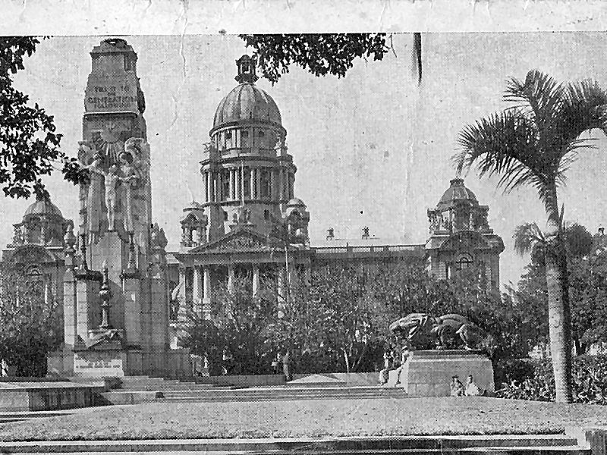Durban Town Hall

Next stop was Bombay remembered by the fact that the sea turned brown some 10 miles out. I believe we had a trip ashore but any detailed memories are indescribably shrouded in a haze of horrible smells and filth.

However, fortunately I was not destined for India, and we transhipped to a smaller ship, I believe named the "Chusan" of some 9000 tonnes, driven by vertical piston steam engines, which resulted in the deck rising and falling a few inches each time the pistons were driven up and down to turn the prop shaft. That must have been one of P&O's oldest ships. This was the only time I was ever affected by sea sickness. Fortunately not badly, but the motion of that ship seemed to bother almost everyone. I have no memories of any escort ships, and on our journey southwards in the Indian Ocean to Ceylon we had a lot of trouble with a submarine, which resulted in continual zig zagging and even travelling in circles at times, to avoid being hit by torpedoes, one of which was actually sighted. I feel I might have had the last word on that one, as you will read later. However, we eventually sailed safely into Colombo.

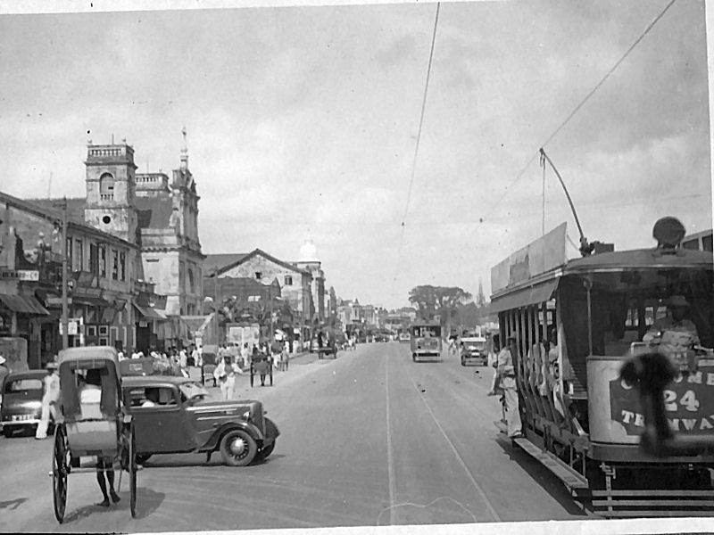

Colombo

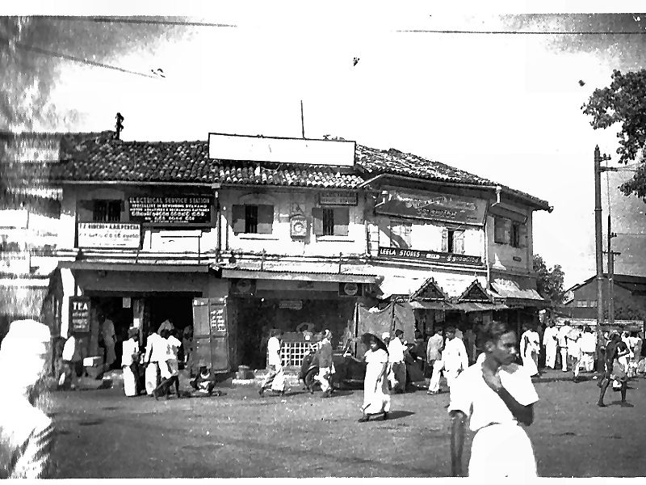

COLOMBO
Although Colombo, does have its slums, it was infinitely preferable to Bombay. We were billeted at the local Golf club with at least a bed to sleep in and a roof over our heads - luxury indeed. I actually played golf once here and decided it was definitely not my game.

Although there was no evidence of any hostile activity on the ground, we were issued with holsters and .38 revolvers and were expected to carry them. We did receive rudimentary training in how to handle, and fire these guns, but that was the only time we fired them, our guns were never loaded, indeed we were never allowed to carry any ammunition. I never saw much point in this exercise, it seemed that someone in the higher echelons of command, was justifying his existence. The population were very friendly and helpful, to the extent that later, I was even able to purchase photographic developing equipment and produce my own photos, and the album still exists. The golf club was on the outskirts of the town and a trip into Colombo centre involved a trip in a Rickshaw, which could be described as a large wicker armchair on wheels with a pair of horizontal poles at the front, between which a sweating native toiled. I always felt slightly uncomfortable at this activity, but it was the only way to travel.

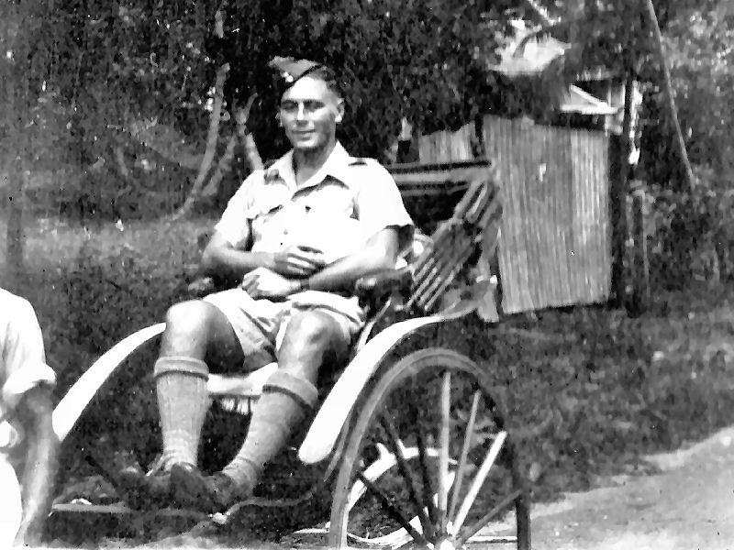

Colombo Rickshaw

The buses were small, designed to carry some 20 persons. They were literally festooned with people, on the roof, on the sides, anywhere there was a perch. There was a tram and train system with the same accommodation problems. The Rickshaw fare for a 2 mile run would be less than a Ceylon Rupee (about 1 shilling and sixpence or 8p). The Ceylon rupee was split into 100 cents the coinage being coins and small notes of 5, 10, 25, and 50 cents. A 25 cent note worth about two pence was quite intriguing, and usually very tatty.

RAF rations being less than exciting - I have never allowed a piece of corn beef to pass my lips since leaving the forces- we often ate out at local restaurants, which were clean and safe providing one observed the basics of cooked food only, no local water, and no washed salads. Our usual order was omelette and chips, which was quite eatable, although the distinctive taste of chips cooked in Palm oil will never be forgotten.

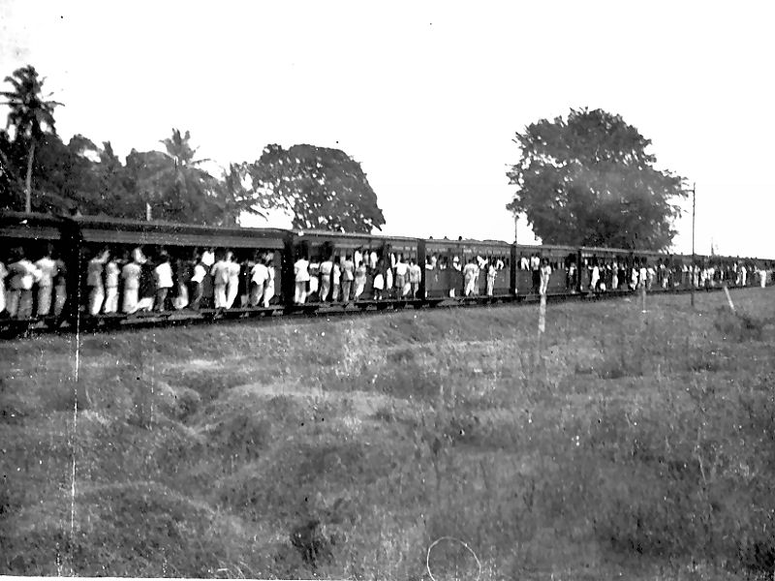
Colombo Train

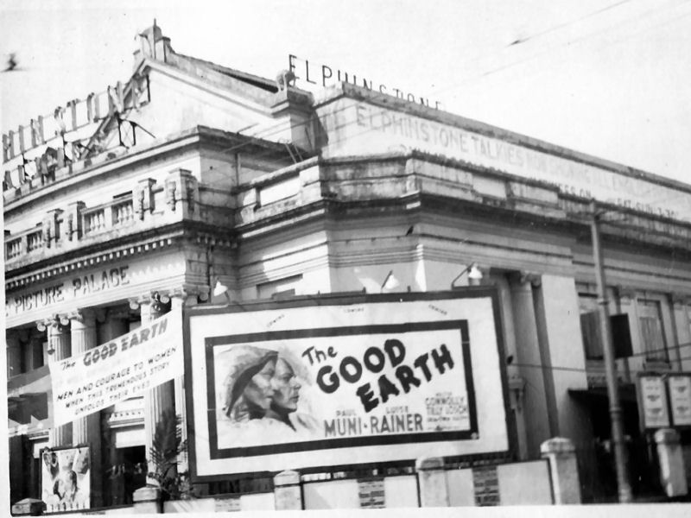
Colombo Cinema

We were accumulating the parts of a mobile radar station here and eventually the orders came through to proceed to Gaul on the South coast of the island. The mobile radar station consisted of 5 Crossley 10 ton lorries, each containing respectively, the transmitter, the receiver, the Diesel generator, the aerial towers, and the personnel. We were 4 lorries, the aerial lorry having gone on before to erect the towers.
The trip involved unmade roads through the jungle for some 60 miles. Interesting indeed, with bridges across ravines made of tree trunks tied together with ropes, where we had to call for a volunteer to drive the first lorry over to see if the bridge was strong enough. Ceylon is on the equator and temperatures were in the 90s with no air conditioning in those days. A sign appeared pointing to a Rest House, and we hopefully followed it to a real haven of comfort, and tranquillity. Lunch was offered to our bedraggled crew, and we relaxed for an hour. The only problem was that lunch consisted of a very hot Curry. In those temperatures, this was the last thing we really needed, particularly as drinking water was in short supply. We were hot enough already. This is the foundation of my hatred of curry to this day.

GAUL
We arrived at Gaul to find the towers duly erected on a low cliff on the sea front. Our job was to site the receiver and transmitter lorries near their respective towers, set up the Diesel generator, and run the appropriate cables. The equipment bore no resemblance whatever to the big CH stations we were used to. The transmitter was an MB2, which just about filled the space in the lorry, fortunately leaving no room for an operator - it was very noisy. The MB2 produced about a 100 Kw of pulse power, half that of the CH stations at home. I touched on the technicalities of the station on our course at Yatesbury, but it was another steep learning curve. At least we did not have the problems of demountable valves. The final power stages of the MB2 were nice glass "bottles" about fist sized, and never gave us any trouble. The weak point in all the gear in the tropics, was cooling fans - usually made by Hoover which had a habit of failing in the middle of the night when I was on call. I have hated Hoovers ever since.

The station operated in the same way as the CH stations, but only had two 100 ft. towers and no redundancy. We could usually manage some 100 miles range, nearly as good as the CH, but considerably smaller and cheaper. We plotted a number of "hostiles" coming in from the sea, but they always turned round about 60 miles out and never again visited Colombo. They were obviously picking up our radar transmissions. We were therefore doing our job of just being there. Although there was a seaplane base near Colombo, I never heard or saw any fighter planes.

Accommodation in Gaul was in commandeered private houses, with good NAAFI and leisure facilities. I was in demand in the NAAFI for my rather average piano playing, just about good enough for sing-songs.

We used to pay the local fishermen a few cents for the use of their fishing boats, outrigger canoes, with the outrigger tied on with rope, and propelled by a sail and paddles. The sea was the usual tropical lagoon with a reef some 200 yards out with large breaking waves. It was always quite exciting, getting across the reef with the knowledge that an upset would deposit us onto the sharp coral of the reef. The outriggers made the boats very stable, provided the palm tree fibre ropes held together. We found an inland lagoon and fitted a sail onto a canoe. That didn't last long. One day there was an incredible turmoil in the water near us from some very large animal or fish, and the shore seemed a much safer place. We also used to go swimming at night on the glorious sandy beaches, marred as usual by the tropical insects in the shape of biting sand flies. It was possible to get sand fly fever, which seemed to be a sort of influenza, and could be quite debilitating.

The climate was very hot and humid with severe thunderstorms at night. The station received a direct lightning strike on both the transmitter and receiver towers, which caused a lot of damage. I was standing by the switchboard when it hit and everything around me blew up in flames. I get cold shivers to this day every time I hear thunder, or even write this. The diesel generator switchboard took the brunt of the strike, being I suppose the shortest route to earth. Strange things happened with this lightning damage. The main aerial feeders were heavy
1 inch diameter coaxial cable and although we restored the power lines and repaired the equipment, nothing would work. We eventually found the feeder cables from the aerials to be open circuit, although looking OK outside. We found on cutting them open to find the break, that large sections of the inner copper conductor were missing, burned out by the lightning. The supply of replacement cable taxed the resources of the "Stores", but they eventually found some.

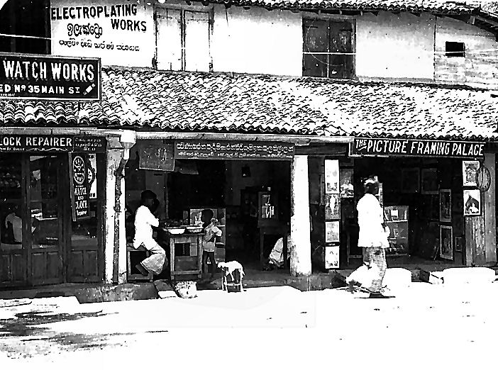
Gaul Shops

Communication with Colombo for reporting positions of aircraft and ships was by short wave radio and here of course we were in our element with a built in ham station to play with, but of course no body to talk to other than the controllers at Colombo

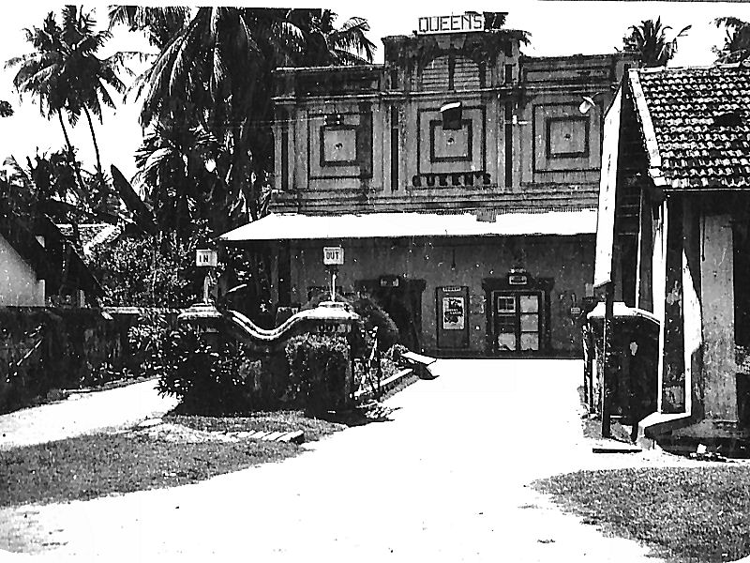

Gaul Cinema

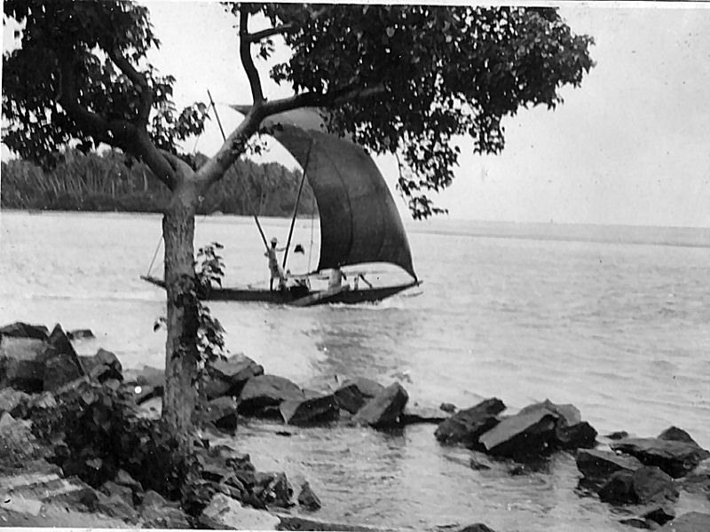

Gaul Fishing
Gaul was an Air Sea rescue base, with RAF personnel operating fast air sea rescue boats. I wangled a trip on one, which was returning to Colombo for maintenance. These boats were quite something, powered by 3 x 500 HP Napier aero engines, giving them a speed of some 50 knots. The engines were set in an engine room at the stern, which was the duty spot of some unfortunate "irk", who had to sit in the heat and noise of those bellowing aero engines. There was nothing he could do anyway but just endure, the engines were controlled from the wheelhouse. It was a highly uncomfortable ride, Ceylon is in the trade wind areas which means constant force 6/7 winds and seas to match. Of course we had to travel at maximum speed and were flying most of the time from wave top to wave top - a definite test of endurance. The subsequent train journey back to Gaul was another learning curve. In tropical countries in those days, and sometimes to this day one does not sit on public seats without protection, especially when wearing shorts. The seats contain all sorts of nasty things, large and small. Our issue gas capes were invaluable for sitting on any chair, even in Cinemas, where the chairs were wickerwork, a nice nesting place for biting bugs. Even recently on a nostalgic return trip to Sri Lanka as it now is, I noticed two ladies of our party sunbathing on wicker recliners. As I expected, they both had the tell-tale wheals of the biting bugs on the back of their thighs, when they stood up.

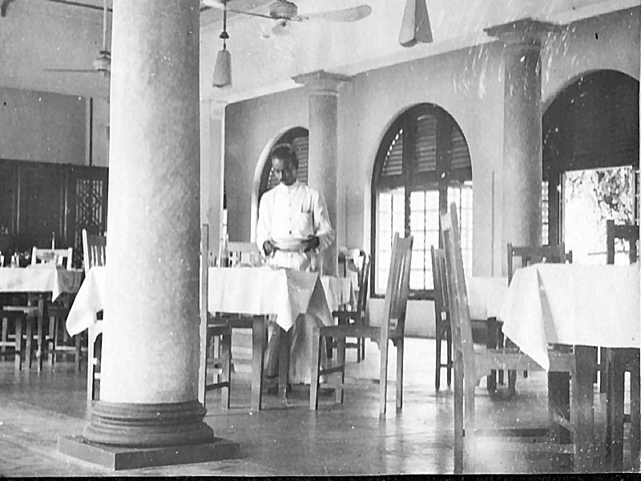

Resthouse dining room

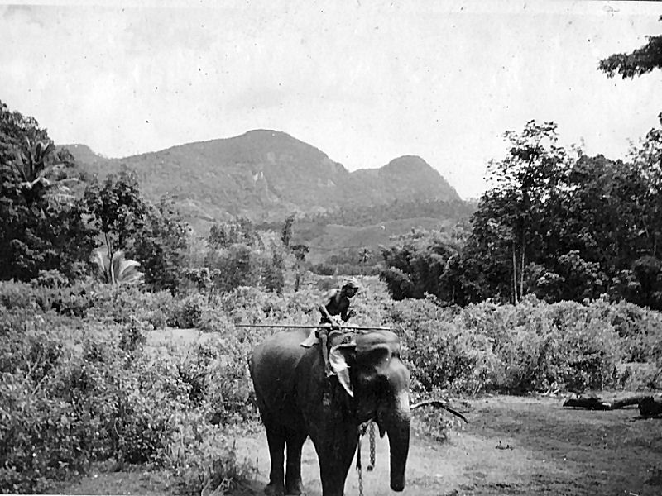

Transport

The recent Civil War between the Tamils and the Singhalese, I just do not understand. They are nice peaceful people. We employed both races, some as Mess boys. The Tamils if anything seemed to be more efficient, but there was no animosity between them. I can only think that they then had a common enemy - us. They always called us Sahib, which we neither liked, nor required. I suppose after the war when we had left, there was no common enemy, and politics came into the equation.

Health in the tropics was a problem and the RAF medical facilities were extremely good. The usual "Prickly heat" as an itchy rash on the back became normal - you just put up with it. Anything more serious resulted in a stay in a small services hospital, and a subsequent visit to a rest home in the mountains, usually the home of one of the tea plantation owners. The climate on the equator at 10,000 ft is perfection, and there were a number of devoted nurses to make life even better.

It seems that nothing changes in Ceylon. On that recent return visit, some 60 years later, we visited a resthouse in the mountains near Kandy, and as I came to the entrance gate I said, I have been here before. There is an entrance porch and a lounge to the left with leather chairs and settees, and the classic picture of "the Stag at Bay" over the mantelpiece. Sure enough it was exactly so, nothing had changed, even the dining room through a door at the end of the lounge was the same vaulted roof and a menu, always consisting of curry.

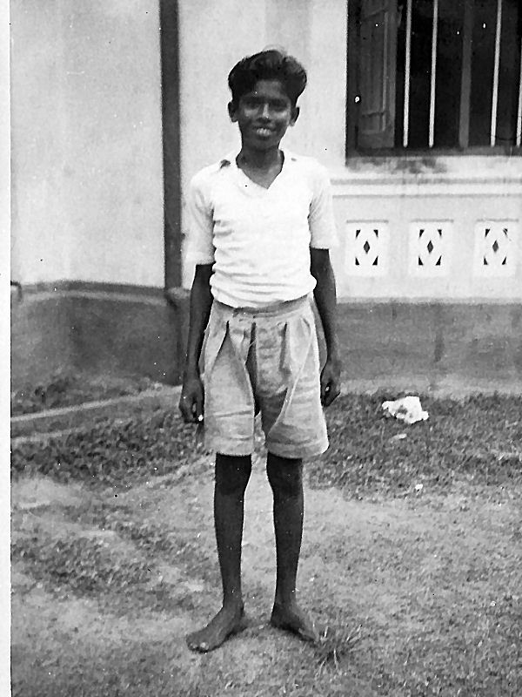

PETER Our Mess Boy

KKS or Kankesanturi which no one could ever spell.

Promotion to Flight Sergeant came, and I was posted to KKS, with more responsibility. We were situated on the north coast of the Island, on the strait between Ceylon and India, and once again we were plotting very few "hostiles". We did however notice a strong, very slow moving echo at about 10 miles range in the same position every night at about 2 am. It was moving too slowly to be an aircraft, and we thought it might be a submarine surfacing to recharge batteries. We reported this to Colombo, together with the position. They sent a Destroyer, to wait for it. Sure enough it was a sub and we never plotted it again! It is very likely that was the one that threatened us with torpedoes on the sea passage from Bombay to Colombo, I always believe I won that one!
.
We had some aerial failures at KKS and this highlighted my love of aerials. There was a certain amount of aerial test equipment available on the station and I was able to use this to sort out the problems.

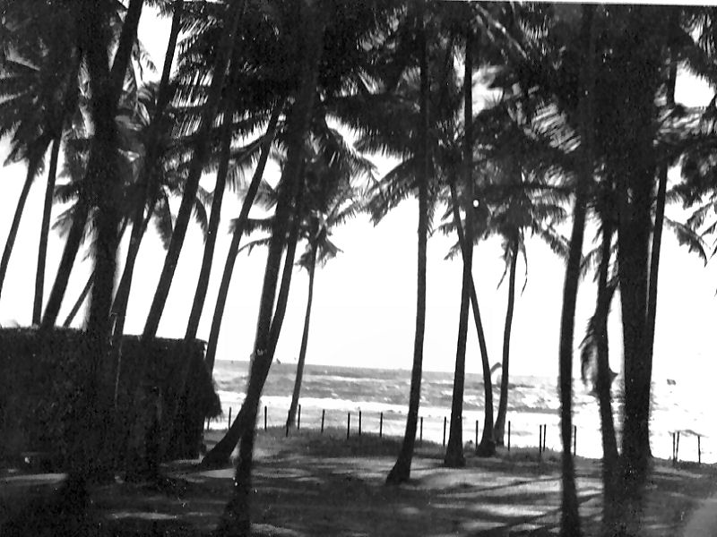

House by the sea

TRINCOMALEE
Posted again. This time, to an entirely different type of radar station, of which I had no technical knowledge whatsoever. This was the embodiment of one of the greatest inventions of the war - the Magnetron. The entire station was just one vehicle trailer, which had a rotating cabin built on to it. The operator sat in the cabin, in front of a sophisticated cathode ray tube system, which showed the actual position of any response up to 100 miles or so. The same performance as the mighty CH stations at home. Amidst all this high power technology, the somewhat incongruous means of rotating the cabin was a set of hand operated bicycle pedals, which the operator had to keep turning, pausing now and again to investigate any interesting response. On top of the cabin was an oblong shaped aerial which produced a narrow beam of high power radiation at a wavelength of 10 cm . This was quite miraculous, such a wavelength was unheard of, and to produce 200 Kw pulse power at that frequency was just unbelievable. We used to hold up a neon lamp many yards from the station and as the beam came round the lamp would light.
All the equipment I dealt with, had very comprehensive technical manuals, and with the help of these and one Radar Mechanic, who had knowledge of the equipment, and was a very good teacher. I learned the technical details, and how to maintain this wonderful station. I was even giving courses to newcomers by the time I left.

The 10cm station together with an old CHL station was set up on a cliff top overlooking the naval base, some 5 miles from our specially constructed billets near the town. I was on 24 hour call again, for emergency maintenance. I had a services driving license, and was allocated a 3 ton Chevrolet lorry to provide transport at any time up to the site. There were two major reliability problems. One was those infernal Hoover blower motors, which were vital to keep the magnetron cool. The magnetron is small enough to sit in the palm of one's hand, and yet it would produce 200Kw of peak power.- it needed cooling! Failure of a blower motor would automatically trip the transmitter, and we were off the air until I got there to replace that motor. The magnetron is in use to this day, not only for Radar, but it also powers your microwave oven.

The other problem was caused by officialdom. It was laid down under RAF maintenance rules that the equipment must be shut down for one hour each day for maintenance (basically polishing the knobs) The problem was, we were in the tropics with high temperatures and very high humidity. All transmitters in those days involved high voltage. In particular, the Magnetron which required the usual 30,000 volts for pulse transmission. Now, high voltage and moisture do not go together. The magnetron transmitter was simple and extremely reliable, so long as it was running and hot. The moment it was shut down in the heat and humidity of Ceylon there was condensation and it took a long time to again get things dry and running. This meant that the maintenance polishing could take a long time during which the station was off the air. In defiance of officialdom I ordered that the daily polishing should cease and from then on we had no more trouble - the station remained operational 24 hours a day, as it would of course nowadays.

Trincomalee had its own filter room manned by WAAFs who used to travel by boat to their work on the other side of the harbour. Very few hostiles were ever plotted at Trinco. The watch on these mobile Radar stations usually consisted of 3 radar operators and 1 Radar mechanic. Sometimes when numbers were reduced due to illness etc the mechanics used to take a turn at operating. Not a very onerous task with mainly the regular local aircraft patrols to plot.

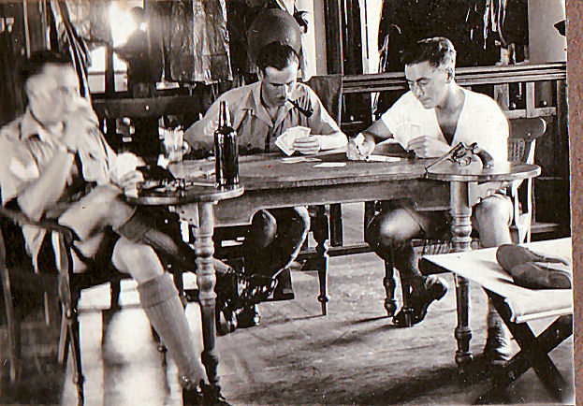

I think it was Solo

We were now getting towards the end of the war, and VE Day came along - the end of the European war. Much cause for celebration, so much so that we set up a large flashing light on the top of the CHL station's rotating aerial, flashing the letter V in Morse. The navy were horrified, remember we were still at war with Japan, although the nearest hostile by then was at least a 1000 miles away. We had to turn the light off, but it was good fun while it lasted.

There came an opportunity for "Mid term leave". This took the form of 3 months at home and the lucky few were decided by ballot, and my name came out of the hat. I was posted to Colombo with promotion to Warrant Officer to await suitable transport to UK.

Around this time I attended an interview to become an Officer, having reached the limit in the non commissioned ranks. This was the time as mentioned earlier when I had the opportunity to defy a senior officer. I was deliberately asked what I did. My rather gleeful reply was "I cannot tell you that sir" and I followed it up with the usual rubbish disseminated by the authorities about eating carrots for night vision etc. I learnt later that this was a deliberate trick question to test my integrity. I apparently passed the interview and as my transport home had materialised, I was on my way to England. Another troop ship, whose name escapes me, but with my senior rank as Warrant Officer, somewhat more comfortable with a cabin to myself. We returned via Suez and the Med. this time, a much shorter, and by then a safer journey. My only memories of this trip were the passage of the Suez canal, literally a ride through the desert, and a very short call at Malta.

Upon arrival in England I was posted as an instructor to a training school at Driffield. This was a problem. I was to instruct on the Radio Altimeter, which I knew nothing about, the Loran system of radio navigation, which I knew nothing about, and Airborne Radar, which used entirely different equipment to ground based radar. The first draft of pupils knew more about things than I did. I guess it did not really matter, it was now close to the end of the war and I was fortunately not returning to Ceylon.

Driffield was an operational aerodrome and I managed to get aboard a Dakota photographic flight to Germany. The Dakota served for many years as a twin engine DC3 airliner and in that role was comfortable and successful. My trip to Germany was very noisy and certainly not comfortable. It was however very educating and horrifying to fly over cities such as Dresden and Dusseldorf, and see the total destruction our bombing had caused. I am well aware that they started it and deserved the retaliation, but surely those days must be remembered as a monument to the utter futility of nations trying to kill each other.

Around this time I was summoned to HQ regarding my officer training, and was faced with the simple question - did I wish to take the Officers Training course and become a regular in the RAF or be demobbed.
There was a very simple answer to that - END OF STORY. I had survived, there WAS a future.

Post Script
Anyone believe in "Guardian Angels"?

1. Suppose I had not been a Radio Amateur.

2. I could have been in The North Sea

3. I could have been in the Burma jungles.

4. I could have been the subject of better bomb aimers.

5. That sub in the Indian Ocean could have hit with its torpedoes.

6. That lightning strike was too close for comfort.

7. I could have missed the mid term leave.

